**DATA LOGGING AND TELEMETRY**

**CHOICES FOR MICROCONTROLLER-**

1. **ARDUINO DUE**:

* It is easier to interface and programming similar to Arduino Uno.
* It has more documentation for different projects and good support online.
* It is a cheaper option.
* But it doesn’t have a strong micro processor and various different qualities as shown in the supporting comparison matrix due to which we don’t prefer it for this project.

1. **F280049C (Already Ordered):**

F280049C is a TI MCU launchpad of C2000 series with on board CAN transceiver.

* The programming will be done on MATLAB Simulink and CCS (Code Composer Studio).
* There are forums for support (not as much as DUE) and various code examples and programs are there for its use provided by both MATLAB and TI.
* Debugging is heavily supported.
* Overall more powerful and has very good microprocessor as shown in comparison matrix.
* MATLAB Simulink support enhances the opportunities and makes the interface very easy to go with.

Comparison matrices are attached in EXCEL sheets.

**Working for SD Card:**

1. Interrupts are to be used to switch between transmission of data and logging of data. We also have a sample code on MATLAB for the same and it can be used successfully for this purpose.
2. Logging of data to be done on either of these 2

* SD Card Module which is more trustworthy and better documented.
* 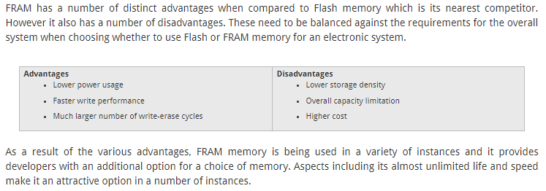FRAM Incorporated within the module which is relatively difficult but faster and cheaper for us.

**Transmission of Data:**

For transmission of data we prefer to choose any of the 2 modules. Both modules communicate through SPI and transmission can be done easily.

1. **Lora SX1272:**

* More difficult to interface and expensive.
* But better range and faster transmission for our use especially since we wish to achieve very high transmission rates.

1. **Digi XBee-PRO® 900HP:**

* Well documented as it’s a XBEE module which is heavily used by people and more trustworthy.
* Enough range for our use but long factory lead time and slower data rates which might create a problem

**Link:**

* https://www.digi.com/products/models/xbp9b-dmst-002

**SIMULINK Support for C2000 MCUs**

Simulink is a very good platform for using the C2000 series. It has its own libraries for it and a bunch load of examples which include codes related to SD Card modules and CAN transmission importantly.

* Also creating blocks on Simulink and its own code generation will help greatly to interface the data logger and its processes.
* Also, its debugging capabilities are very good which would help us greatly.
* Not only that with the pretty hard compared interface of CCS, Simulink is easier to understand and use.

**Link:**

* <https://in.mathworks.com/help/supportpkg/texasinstrumentsc2000/setup-and-configuration.html>

**Working for Microcontroller Module:**

* IMU and IR need to be integrated into the same CAN bus as the one coming from ECU since there is only one inbuilt CAN. This will not be a problem since we would be knowing the CAN IDs of all the sensors from which we acquire data.
* SPI protocol for SD card reader and the use of interrupts from which we will store data on the SD Card.
* ADC channels for POT directly to the analog inputs of the Microcontroller. The data from the analog read will be sampled and converted to a digital signal which will then be processed using inbuilt filter functions in the Microcontroller itself.
* Digital input for wheel speed.
* 1 SPI for XBee via Microcontroller from which data will be transmitted.
* 1 CAN 2.0A for receiving data through CAN bus and storing it in the SD Card.
* Timed Interrupts to be used to send data through the RF module at regular intervals to store data simultaneously in the SD card.
* Data to be stored in SD card through MATLAB MAT-file logging and CSV file automatically made from it which can then be manipulated.
* Then the data points can be saved in: Structure, Structure with time, or Array format.

**Link:** <https://in.mathworks.com/help/supportpkg/raspberrypi/ug/sd-card-logging.html>

* Device Driver for Adafruit Data Logger Shield
  + This uses s-function builder of Simulink to create a library for the SD card shield which can be used with the microcontroller.
  + Link: <https://dashboardproject.wordpress.com/2015/12/29/simulink-device-driver-for-adafruit-data-logger-shield/>
* CAN Communication via Simulink:

Link:

* <https://in.mathworks.com/help/vnt/can-simulink-communication.html>
* <https://in.mathworks.com/help/vnt/basic-can-communication.html>
* Watchdog timer for C2000
  + Link:<https://in.mathworks.com/help/supportpkg/texasinstrumentsc2000/ref/c28xwatchdog.html>
* Filtering messages according to identifier-
  + This will filter all the messages we receive directly at the microcontroller end and remove noise. Example data received from the linear pots.
  + Link: <https://in.mathworks.com/help/vnt/filter-messages.html>